Find perfect-fit clients who need your expertise in 3-steps

Nicolas Cole
May 07, 2025
∙

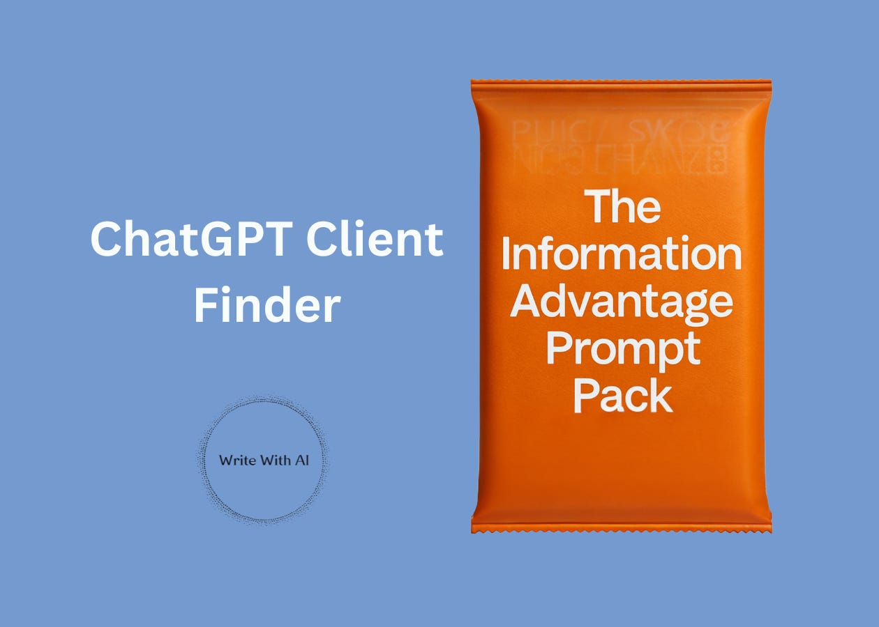

Hey there!
Yesterday, I showed you how to unlock your Information Advantage.
But having specialized knowledge isn’t enough. The real challenge is connecting that expertise with the exact people who need it (and are ready to pay for it). Most writers spend years chasing the wrong clients, underpricing themselves, and taking whatever work they can get.
Right now, there are clients who would see your knowledge as the perfect fit—they just don’t know you exist yet.
So today, I’m going to show you how to find those dream clients in 3 steps with the help of ChatGPT.
Let’s get into it.
Step 1: Map Your Information Advantage Onto An Industry
The first step to finding your dream clients is connecting your expertise to industries with expensive, recurring problems.
This is where most writers mess up. They describe themselves by what they do ("I write content") instead of what they know ("I understand endurance athletes" or "I’ve spent 10 years learning the psychology of wellness buyers"). But when you lead with knowledge, not just services, you unlock the ability to charge more—and work with clients who value your brain, not just your output.
To do this, you need to first ask:
Which industries would benefit most from what I already know?
If you know yoga, that’s not an industry. If you’re obsessed with building modular synths, that’s not an industry. Those are Information Advantages. Your job is to map that advantage onto industries where your knowledge is already useful, relevant, and monetizable.
For example:
If your Information Advantage is “analog synthesizers and modular synth building,” potential industries might include:
- Music technology (companies making synth hardware, DAWs, plug-ins)
- Pro audio equipment manufacturing (boutique gear makers, component suppliers)
- Music education (online courses, production schools, tutorial platforms)
- Recording/engineering services (gear reviewers, audio service providers)
- Independent publishing (music zines, niche blogs, sound design platforms)
Notice: we’re not naming specific job titles or companies yet—we’re zooming out to find the fields where your knowledge would be seen as an asset.
Give this to ChatGPT or Claude to get a focused list of 3–5 industries where your Information Advantage is valuable:
Here’s the prompt:
I'm going to share a personal interest, hobby, or area of expertise that I'm genuinely passionate about.

This could be anything from golf to airplane miniatures to ultramarathon running - something where I've naturally accumulated knowledge because I enjoy it or have years of experience building a skill in that area.

Based on my Information Advantage, I'd like you to identify 3-5 industries or niches where:

- My knowledge would be valuable to potential clients
- I'd naturally connect with professionals in those fields
- My passion would shine through in my writing

Example: If my Information Advantage is "analog synthesizers and modular synth building," potential industries might include music technology companies, audio engineering publications, and boutique synthesizer manufacturers.

Are you ready for my Information Advantage?
This will give you a list of viable industries that speak your language—which is the foundation of positioning and step one to landing better clients.
Step 2: Find Industry-Specific Clients That Need Your Help
Once you've identified promising industries, it's time to drill down to the exact people within those industries who:
- Have budget authority (can say "yes" without asking permission)
- Face expensive problems your expertise helps solve
- Value their personal brand and content strategy
These aren't just any prospects—they're dream clients who'll pay premium rates because they understand the ROI of your specialized knowledge.
For example, within the wellness industry, a CMO at a supplement company has very different needs and budget constraints than a solo functional medicine practitioner. Both might need your expertise, but they represent different client profiles requiring different approaches.
The following prompt will help you identify specific roles within your chosen industry who are most likely to be high-value clients:
I'm interested in writing for [INDUSTRY].

Please:

Break it into 3-4 major subcategories

For each subcategory, provide 2-3 specific niches

For each niche, list 3 specific potential clients who have income and motivation to invest in personal branding and scaling themselves online.

Format with clear hierarchy using bullet points.

Topic / Area

- Subcategory
- Specific Who

The key is choosing people who:

- Have disposable income
- Need to build authority
- Want to attract clients/opportunities
- Value their time (and will pay for help)

Note, I'm not looking for specific people. I'm looking for the roles of target clients.
Run this prompt with your chosen industry, and you'll have a precise map of ideal client roles to pursue.
Step 3: Locate Your Dream Client Watering Holes
Dream clients don’t magically appear in your inbox.
You have to go where they already spend their time (and earn their attention). High-ticket clients hang out in very specific places usually tied to their industry, role, or problem. If you want better leads, you need to embed yourself in their existing ecosystems.
Here are the most common “watering holes” for serious buyers:
- Industry-Specific LinkedIn Groups
- Virtual & In-Person Conferences
- Trade Newsletters or Blogs
- Professional Associations
- Online Communities (Slack, Discord, Reddit)
These are the places where buyers share problems, ask for recommendations, and seek trusted experts.
Instead of wasting time trying to find all these on your own, you can use AI to find and ultimately infiltrate these spaces—so when a client needs help, you’re already there.
Here’s the prompt:
I'm targeting [SPECIFIC CLIENT ROLE] in the [INDUSTRY] industry with my ghostwriting services.

For this specific client type, please help me identify:

1. Top 5 industry-specific conferences or events they likely attend
2. 3-5 online communities or forums where they actively participate
3. Primary social media platforms where they engage professionally
4. 5-7 industry publications, newsletters, or blogs they likely read
5. 3-5 podcasts popular in their industry
6. 2-3 professional associations they might belong to
7. Types of search terms they might use when looking for content help

For each category, explain WHY this particular client type would be drawn to these spaces (what value they get, what problems they're trying to solve, or what opportunities they're seeking).

Also identify 1-2 "unexpected" places these clients might gather that most writers would overlook.
This prompt gives you a shortcut to what normally takes hours of digging.
And it sets you up to start building relationships where your ideal client hangs out.
Note: I recommend using ChatGPT’s Deep Research tool for this prompt because it’s optimized for layered, multi-step research—unlike regular chat, which often gives surface-level answers without context, justification, or depth.
That’s it.
Now you know how to map your Information Advantage, identify the industries that need it, and find the exact watering holes where your dream clients are already spending time.
Tomorrow, I’ll show you how to turn that research into a positioning statement so clear and specific that ideal clients instantly get what you do—and want to hire you for it.
For now, use these strategies to build a target list of at least 20 ideal clients.
Then comment below and tell me: What type of client did you identify that you hadn't considered before?
Chat soon,
—Dickie & Cole

